CSA0619-Design and Analysis of Algorithm
CO5-AT1
Longest Path Problem (NP-Hard Problem)
Aim:
To find the longest simple path between two vertices in a graph using a backtracking approach, while enforcing vertex non-repetition and path continuity constraints and using pruning to reduce unnecessary exploration.
Problem Identification:
The Longest Path Problem asks us to find the longest possible path between two specified vertices in a graph.
A path is considered simple when no vertex occurs more than once.
For example:
0 → 1 → 3 → 4 → 5
is a valid simple path because every vertex occurs only once.
But:
0 → 1 → 3 → 1 → 5
is invalid because vertex 1 is repeated.
Algorithm
- Read the number of vertices and edges.
- Construct the graph using an adjacency list.
- Read the starting and destination vertices.
- Mark the starting vertex as visited.
- Start the backtracking process.
- Select an unvisited adjacent vertex.
- Add it to the current path.
- Mark it as visited.
- Recursively explore the new vertex.
- If the destination is reached, compare the current path with the best path.
- Use pruning to discard branches that cannot produce a longer path.
- Backtrack by removing the current vertex.
- Continue until all possible paths are explored.
- Display the longest simple path and its length.

Source Code:
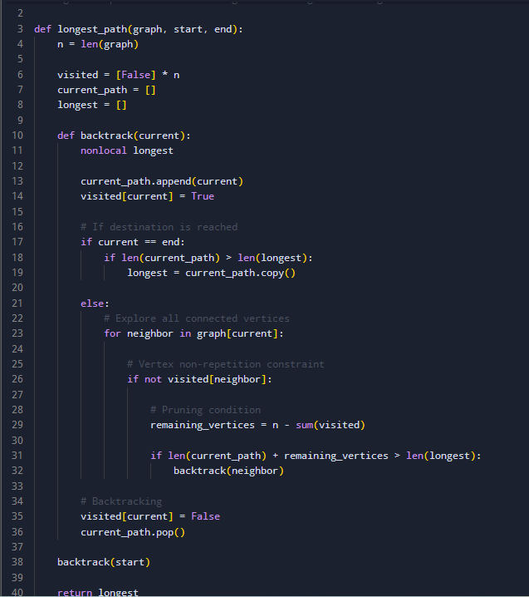
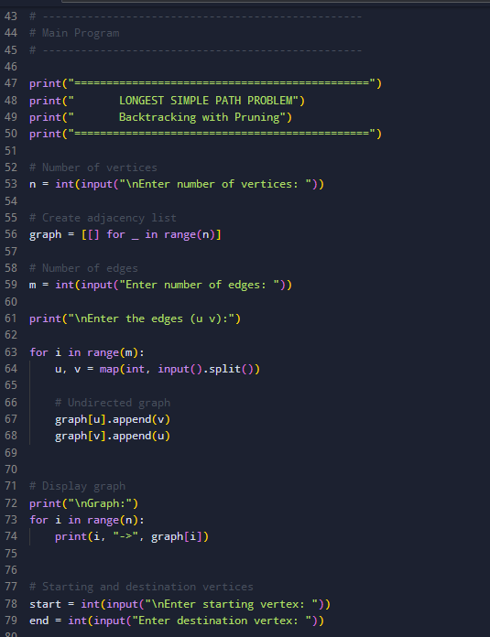
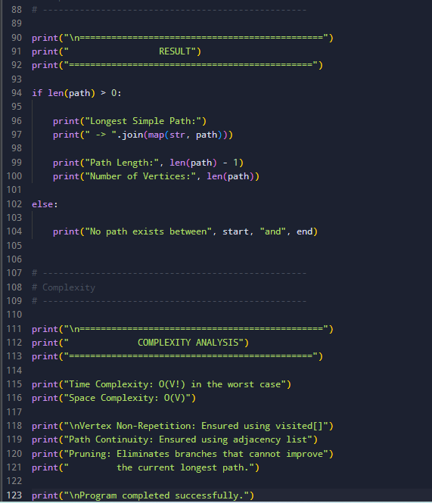

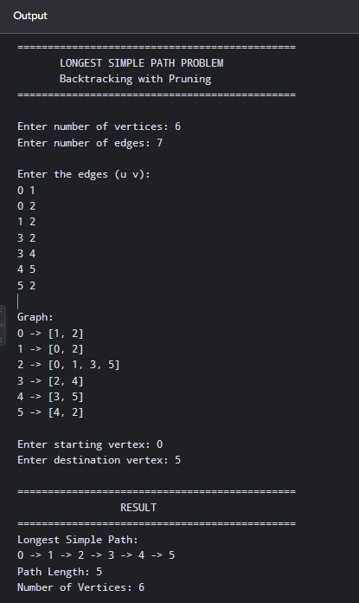
Output:

Time Complexity: O (V!)
Space Complexity: O(V)
Report Analysis:
The Longest Path Problem was implemented using a backtracking approach with pruning. The algorithm explores different possible paths between the given starting and destination vertices and keeps track of the longest valid simple path. The vertex non-repetition constraint is maintained using a visited [] array. This prevents the same vertex from being included more than once and avoids cycles. The path continuity constraint ensures that the algorithm moves only between vertices connected by an edge.

